Handheld for

Advanced Training on Cloud-based Website CMS Using Wix

Login in Class Room PC
Account: (UID, NO need to input @hku.hk)
Password: (UID password)

Agenda
https://www.hkumockup.its.hku.hk/

Training Material
- Login your HKU email https://hkucc1.hku.hk/owa/ , find an email subject
“You're Invited to Become a Website Contributor” click the “Accept Now”
- Click “Login to accept” if you already signup a Wix account, otherwise, click “Create account & accept” to sign up a new Wix account.
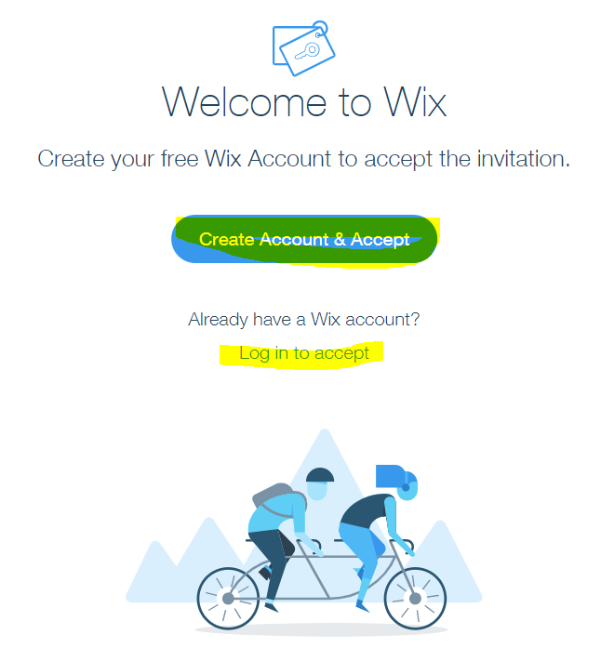
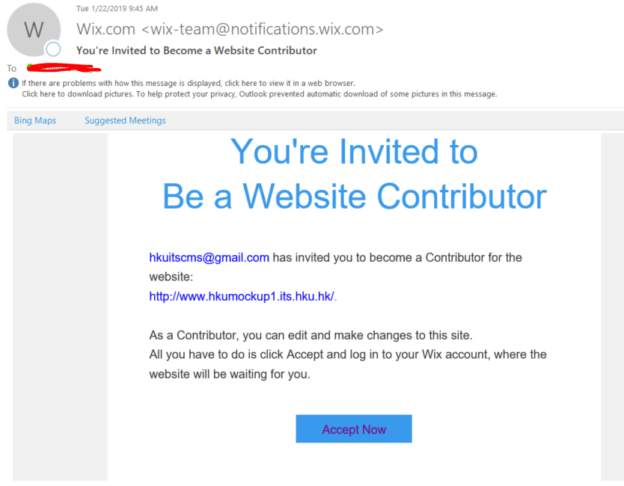

- From the site list, select the one named with Wix Advanced XX, click “Select & Edit Site”
- The Wix site assigned to you already in production, visit https://www.hkumockupxx.its.hku.hk
- Visit https://www.hkumockup.its.hku.hk/
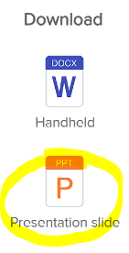
- Download the presentation slide from https://www.hkumockup.its.hku.hk/

May sure you got below 5 training materials:

Dashboard | Editor
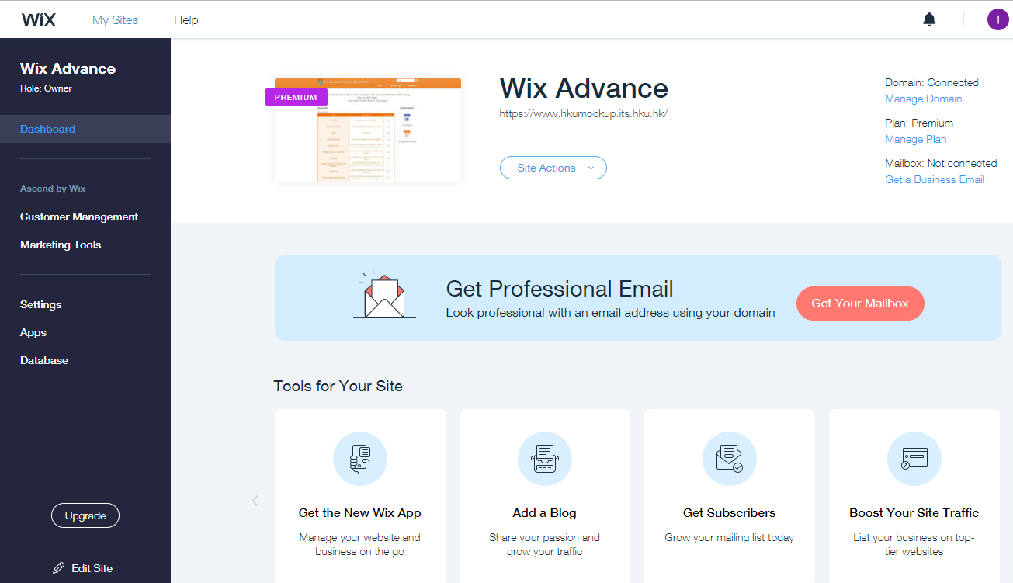 | 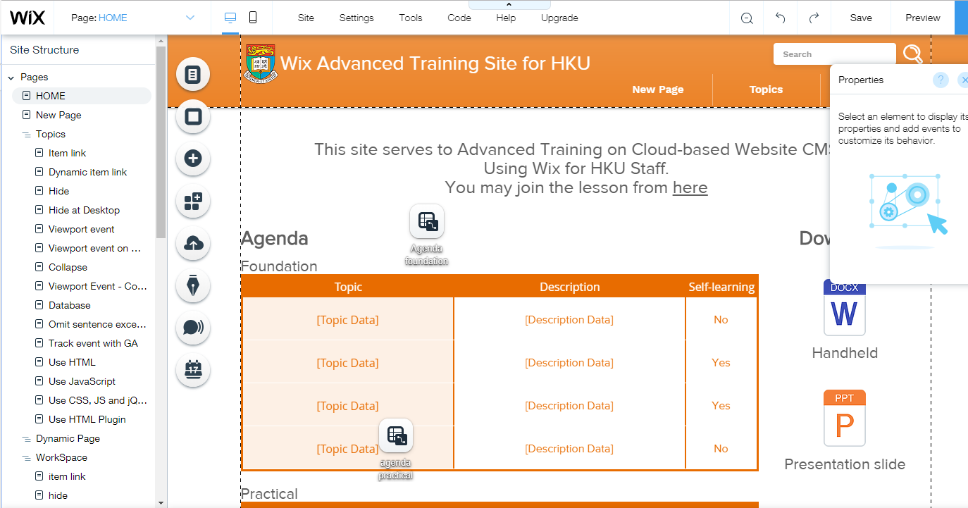
Production site  https://www.hkumockupXX.its.hku.hk | Demo site  https://www.hkumockup.its.hku.hk
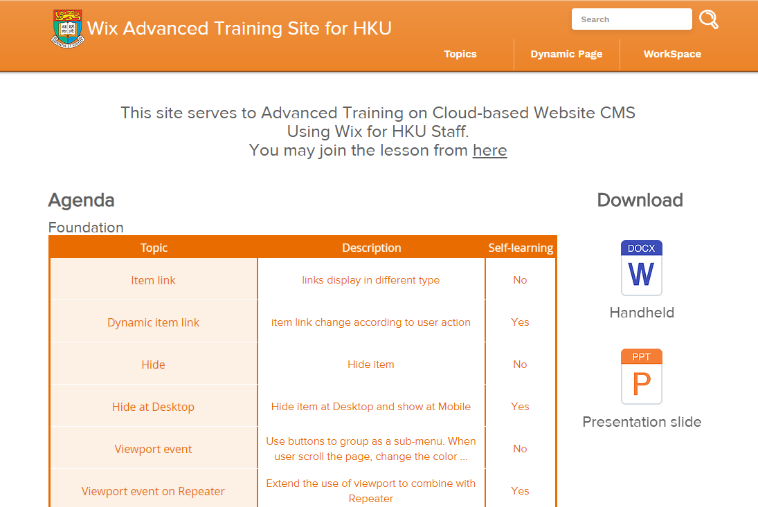 | 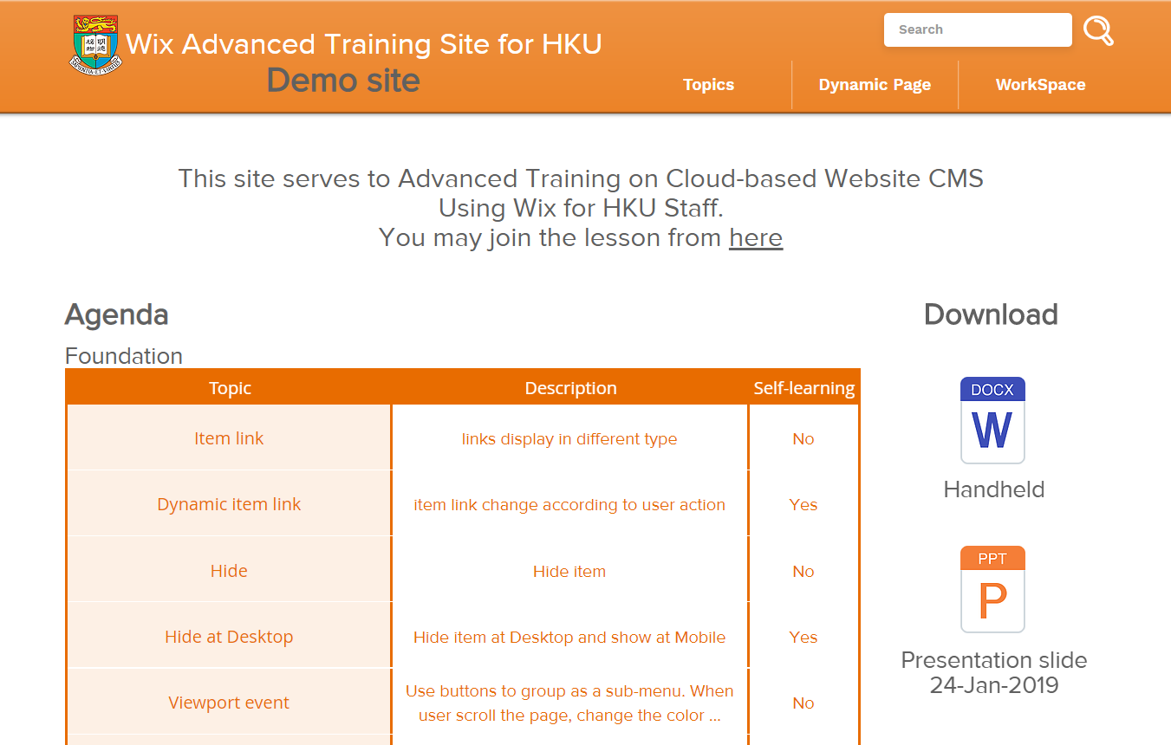
Presentation Slide
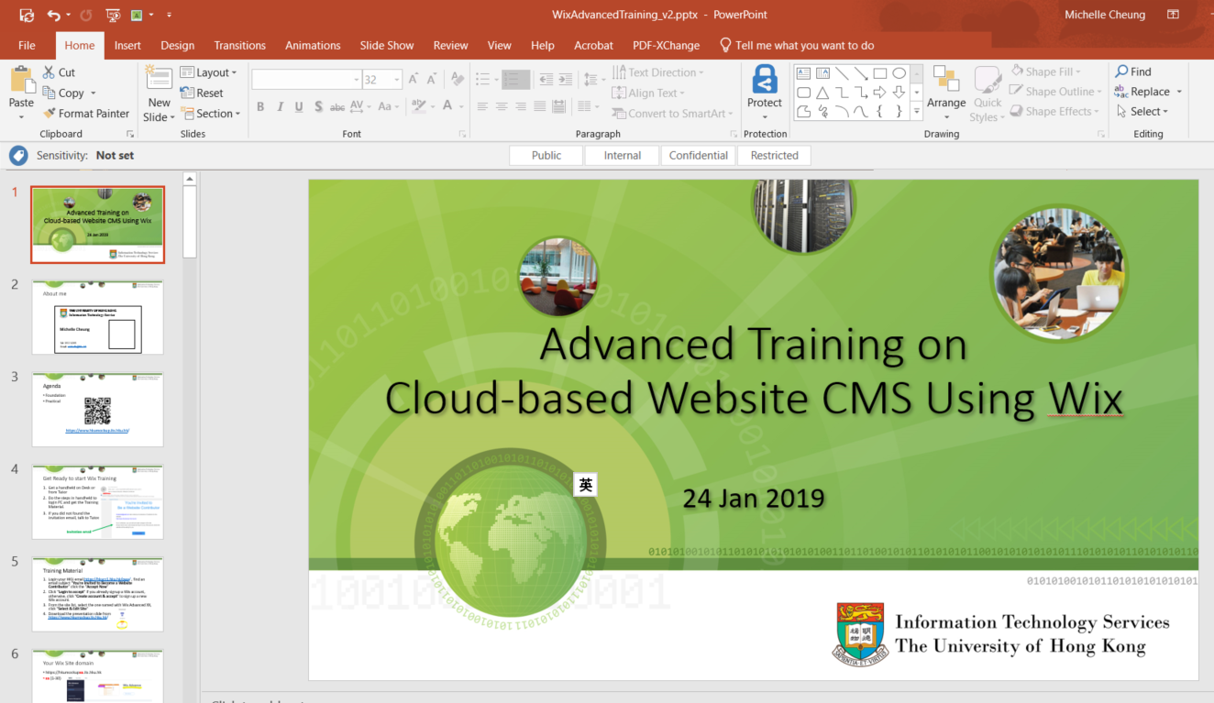

Remark
- After the lesson, the Wix site assigned to you for training will be duplicated and transfer to your account on the next working day (excluded premium plan and domain). The original one will be deleted after 5 working days. You may email me michellc@hku.hk if you didn’t receive the email about site transfer before delete. (you need to accept the site transfer within 3 days)

Questionnaire

